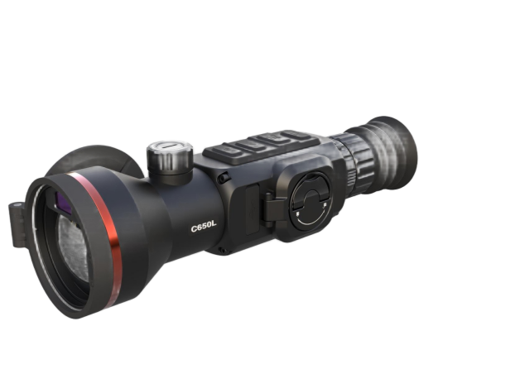

LYCAN LN650L

Thermal Scope

Thermal Image Scope is equipped with a 640 x 512 thermal detector and a 1024 × 768 AMOLED display. Boasting ultra-high thermal sensitivity, it delivers clear target recognition even in harsh weather and low temperature difference scenarios. Featuring long battery life and a maximum observation distance of 2600m, this scope is ideal for hunting, outdoor patrol, search and rescue.

Key Features
- 640×512 resolution with 12 μm sensor, 50Hz frame rate
- High sensitivity thermal module NETD ≤ 15 mK (25°C, F# = 0.9)
- 1024 × 768 resolution 0.39-inch AMOLED display
- 50mm F0.9 lens, observation distance up to 2600 m
- Up to 10 hours of continuous operation at 25°C
- 4 replaceable and rechargeable Li-ion batteries, battery non-polar design for normal operation in forward and reverse installation
- Built-in 905nm Class 1 laser rangefinder (1.2km, ±1m accuracy) and ballistic calculation
- Supports audio recording, snapshot and recoil-activated recording
- IP67 protection grade, operating temperature: -20°C ~ +50°C
- High shock resistance up to 1000 g/0.4 ms
- Wi-Fi connection and 64GB built-in storage available

n Specification
Thermal Module
Image Sensor | UFPA (VOx)
Resolution | 640×512
Pixel Pitch | 12µm
Frame Rate | 50Hz
NETD | ≤15mk
Spectral Range | 8-14µm
Optical Parameter
Focal length / Aperture | 50mm; F0.9
Field of View | 8.7°×7.0°
Base Magnification | 2.7X
Focusing Mode | Focus Knob
Eye Relief | 40mm
Exit Pupil | 6mm
Diopter | +5D to -5D
Detection Range | 2600m (Human; 3pixels)
Recognition Range | 640m (Human; 12pixels)
Image Display
Screen | AMOLED, 0.39 inch
Resolution | 1024×768
Screen Brightness Adjustment | Support
Brightness Adjustment | Support
Contrast Adjustment | Support
Image Enhancement | Support
Scene Mode | City;Plain;Forest
Display Mode | Circle;Box
Color Palette | White Hot/Black Hot/Red Hot/Fusion/Golden Hot etc.
Digital Zoom | 1×; 2×; 4×
Power Supply
Battery type & Number | 4 replaceable 18350 Lithium batteries
External Power Supply | DC 5V (USB Type-C)
Battery Operating Time | ≥10h （25℃）
System
Record Video | Support
Capture Snapshot | Support
Audio Recording | Support
Local Album | Support
Recoil Activation Recording | Support
Picture in Picture | Support
Hot Track | Support
Zeroing Adaptation Mode | Support
Screen Adaptation | -
Standby Mode | Support
Ballistic Calculation | Support
Ballistic Calibration | Support
Distance Measurement | Support
Zeroing Profiles | 10
Reticle Pattern | 8
Reticle Pattern | 6
Aim Point Type | 3
Aim Point Colour | 6
BC Aim Point Type | 5
BC Aim Point Colour | 4
Ranging Cursor Type | 3
Ranging Cursor Colour | 3
Peripheral
Electronic Compass | Support
Attitude Sensor | Support
WIFI /APP | Support; 2.4G
Storage | Built-in EMMC (64GB)
Laser Rangefinder | 905nm;Class 1 Laser Safety
Ranging Distance & Accuracy | 1.2 Km*; ±1m
General
Data Transmission Interface | USB (Type-C)
Protection Level | IP67
Operating Temperature | -20°C to +50°C
Max. Recoil | 1000g/0.4ms
Weight（without battery） | ≤665g
Dimension | 252×86×69（mm）

